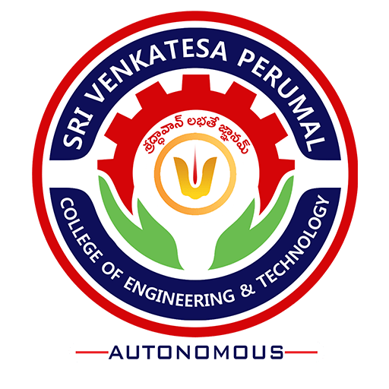

Students’ Attributes
(Revised)

November 2018
Sri Venkatesa Perumal College of Engineering and Technology
(Autonomous)
RVS Nagar, Puttur, Chittoor(Dist) - 517583
www.svpcet.org

CONTENTS

S. No | Topics | Page Number
1 | Students’ Attributes | 01
2 | Students’ Outcomes | 05

Students’ Attributes
The institution strives through its curricular, co-curricular and extracurricular activities delivering generic attributes to students enabling them to achieve success in their studies beyond :
- Attitude
- Academic skills
- Interpersonal skills
- Self-motivation and self-discipline
- Time-management
- Perceptiveness
Specific attributes that enable the students for successful engineering professions are

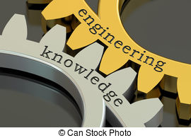 | Engineering knowledge:  Apply the knowledge of mathematics, science, engineering fundamentals, and an engineering specialization to the solution of complex engineering problems.
Problem analysis:
Identify, formulate, review research literature, and analyze complex engineering problems reaching substantiated conclusions using first principles of mathematics, natural sciences, and engineering sciences.
 | Design/development of solutions: Design solutions for complex engineering problems and design system components or processes that meet the specified needs with appropriate consideration for the public health and safety, and the cultural, societal, and environmental considerations.
Conduct investigations of complex problems:
Use research-based knowledge and research methods including design of experiments, analysis and interpretation of data, and synthesis of the information to provide valid conclusions.
Modern tool usage:
Create, select, and apply appropriate techniques, resources, and modern engineering and IT tools including prediction and modeling to complex engineering activities with an understanding of the limitations.
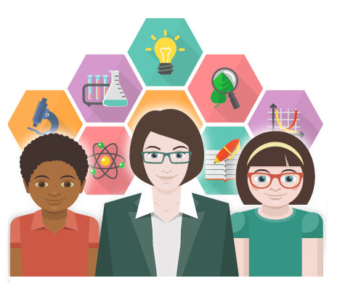 | The engineer and society:  Apply reasoning informed by the contextual knowledge to assess societal, health, safety, legal and cultural issues and the consequent responsibilities relevant to the professional engineering practice.
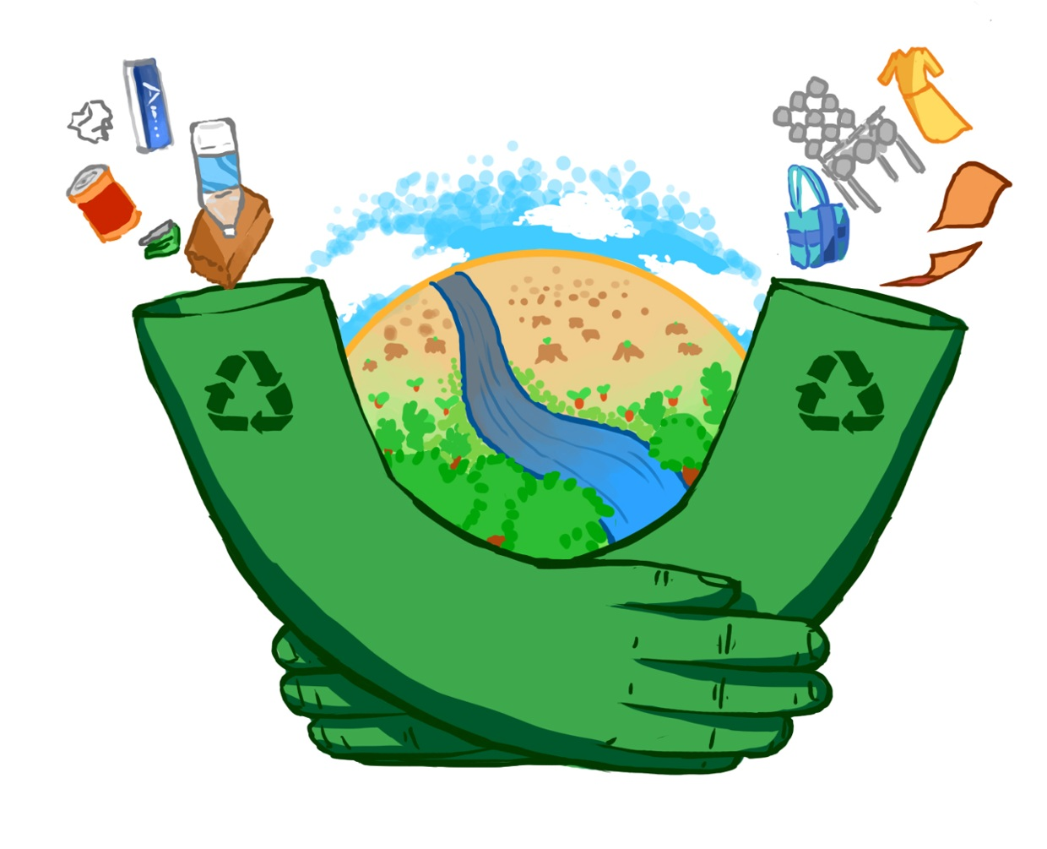 | Environment and sustainability:  Understand the impact of the professional engineering solutions in societal and environmental contexts, and demonstrate the knowledge and need for sustainable development
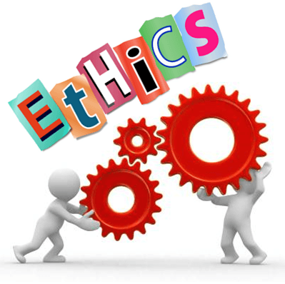 | Ethics:  Apply ethical principles and commitment towards professional ethics and responsibilities and norms of the engineering practice.
Individual and teamwork:
Function effectively as an individual, and as a member or leader in diverse teams, and multidisciplinary settings.
Communication:
Communicate effectively on complex engineering activities with the engineering community and with society at large, such as being able to comprehend and write effective reports and design documentation, make effective presentations, by giving and receiving clear instructions.
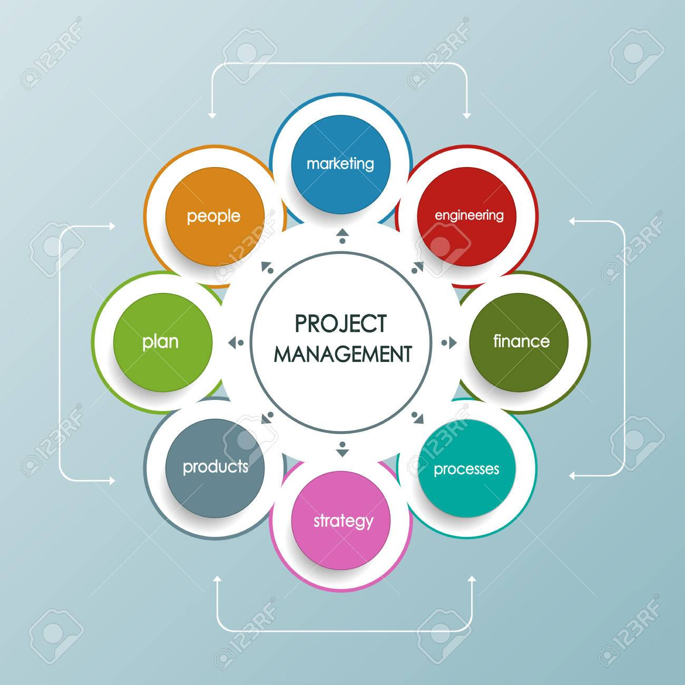 | Project management and finance:  Demonstrate knowledge and understanding the engineering and management principles and apply these to one's work, as a member and leader in a team, to manage projects and in multidisciplinary environments.
Life-long learning:
Recognize the need for, and have the preparation and ability to engage in independent and life-long learning in the broadest context of technological change

Student Outcomes
Progression to Higher Studies | Securing Career
Opportunities for Entrepreneurship | Attitude for Continuous Learning

